|  |
| --- |
| Classification of Mammals |

|  |
| --- |
| 1. CAT |

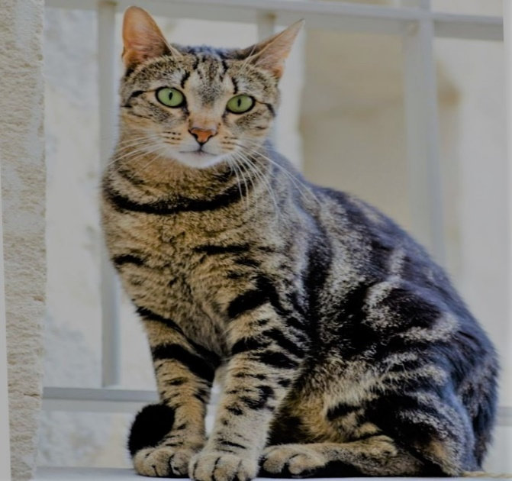

**Conservation Status:**

Domesticated

**Scientific Classification:**

|  |  |
| --- | --- |
| **Kingdom** | Animalia |
| **Phylum** | Chordata |
| **Class** | Mammalia |
| **Order** | Carnivora |
| **Sub-order** | Feliformia |
| **Family** | Felidae |
| **Sub-family** | Felinae |
| **Genus** | *Felis* |
| **Specie** | *F.catus* |

|  |
| --- |
| 1. DOG |

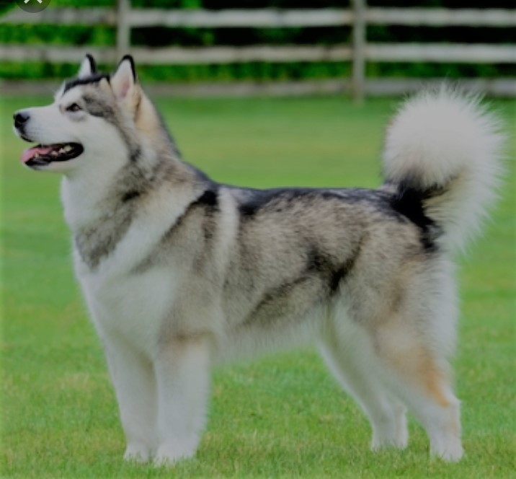

**Conservation Status:**

Domesticated

**Scientific Classification:**

|  |  |
| --- | --- |
| **Kingdom** | Animalia |
| **Phylum** | Chordata |
| **Class** | Mammalia |
| **Order** | Carnivora |
| **Family** | Canidae |
| **Genus** | *Canis* |
| **Specie** | *C.lupus* |
| **Sub-Specie** | *C.l.familiaris* |

|  |
| --- |
| 1. TIGER |

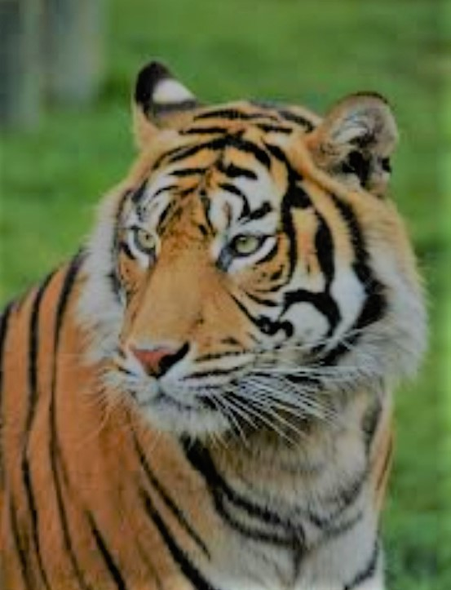

**Conservation Status:**

Endangered

**Scientific Classification:**

|  |  |
| --- | --- |
| **Kingdom** | Animalia |
| **Phylum** | Chordata |
| **Class** | Mammalia |
| **Order** | Carnivora |
| **Sub-order** | Feliformia |
| **Family** | Felidae |
| **Sub-family** | Pantherinae |
| **Genus** | *Panthera* |
| **Specie** | *P.tigis* |

|  |
| --- |
| 1. LION |

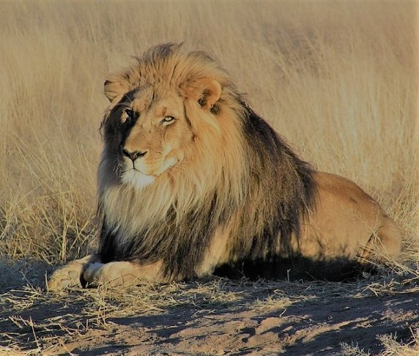

**Conservation Status:**

Vulnerable

**Scientific Classification:**

|  |  |
| --- | --- |
| **Kingdom** | Animalia |
| **Phylum** | Chordata |
| **Class** | Mammalia |
| **Order** | Carnivora |
| **Sub-order** | Feliformia |
| **Family** | Felidae |
| **Sub-family** | Pantherinae |
| **Genus** | *Panthera* |
| **Specie** | *P.leo* |

|  |
| --- |
| 1. HIPPOPOTAMUS |

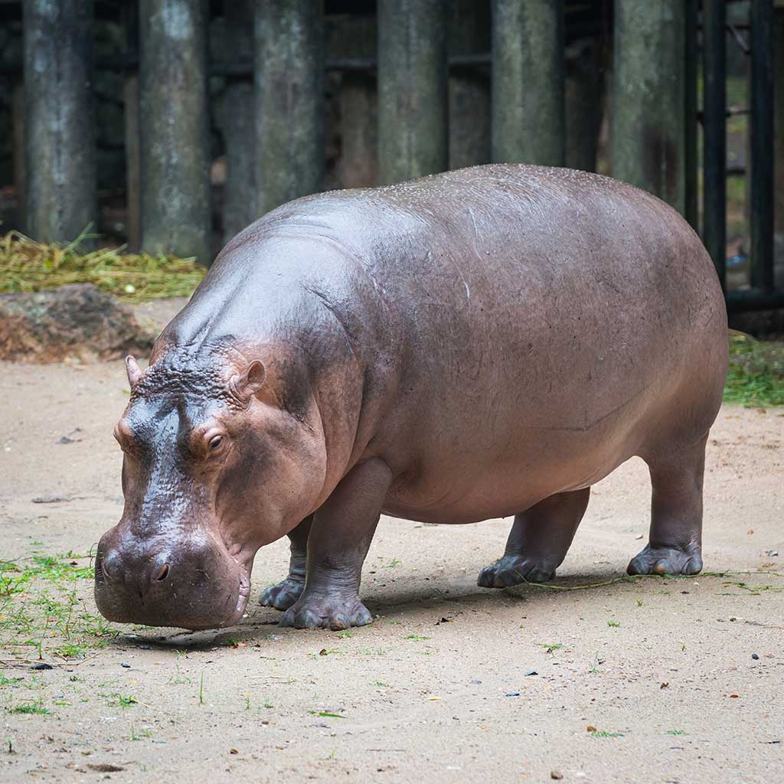

**Conservation Status:**

Vulnerable

**Scientific Classification:**

|  |  |
| --- | --- |
| **Kingdom** | Animalia |
| **Phylum** | Chordata |
| **Class** | Mammalia |
| **Order** | Artiodactyla |
| **Family** | Hippopotamidae |
| **Genus** | *Hippopotamus* |
| **Specie** | *H.Amphibius* |

|  |
| --- |
| 1. RHINOCEROS |

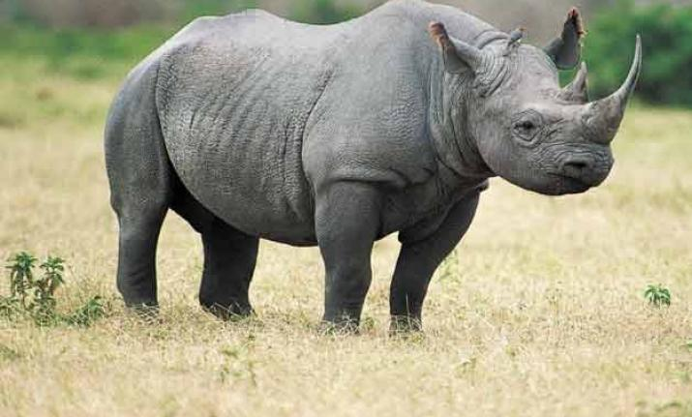

**Conservation Status:**

Critically Endangered

**Scientific Classification:**

|  |  |
| --- | --- |
| **Kingdom** | Animalia |
| **Phylum** | Chordata |
| **Class** | Mammalia |
| **Order** | Perissodactyla |
| **Family** | Rhinocerotidae |
| **Genus** | *Diceros* |
| **Specie** | *D.bicornis* |

|  |
| --- |
| 1. JACKAL |

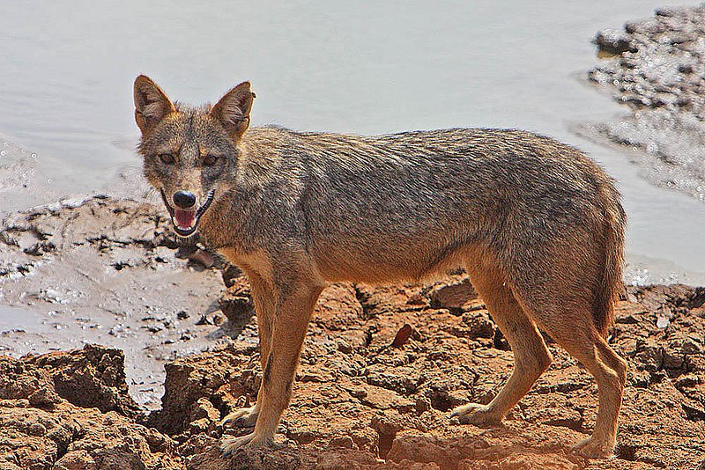

**Conservation Status:**

Least Concern

**Scientific Classification:**

|  |  |
| --- | --- |
| **Kingdom** | Animalia |
| **Phylum** | Chordata |
| **Class** | Mammalia |
| **Order** | Carnivora |
| **Family** | Canidae |
| **Genus** | *Canis* |
| **Specie** | *C.aureus* |

|  |
| --- |
| 1. ELEPHANT |

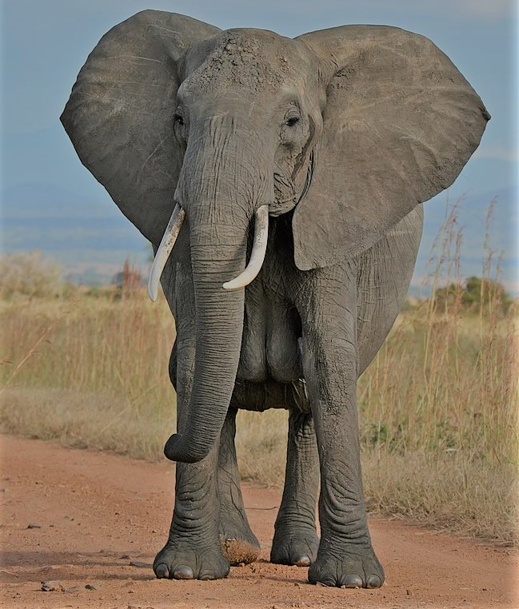

**Conservation Status:**

Vulnerable

**Scientific Classification:**

|  |  |
| --- | --- |
| **Kingdom** | Animalia |
| **Phylum** | Chordata |
| **Class** | Mammalia |
| **Order** | Proboscidea |
| **Family** | Elephantidae |
| **Sub-family** | Elephantinae |
| **Genus** | *Loxodonta* |
| **Specie** | *L.adaurora* |

|  |
| --- |
| 1. CAMEL |

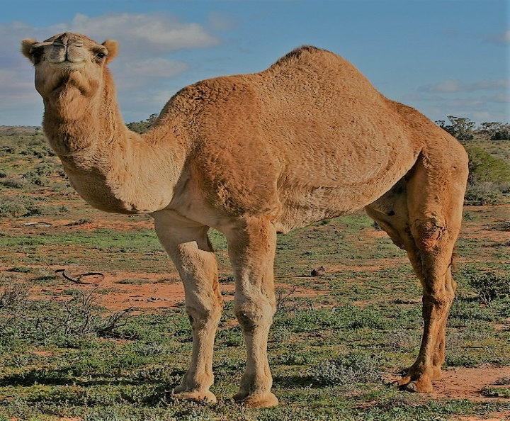

**Conservation Status:**

Critical Endangered

**Scientific Classification:**

|  |  |
| --- | --- |
| **Kingdom** | Animalia |
| **Phylum** | Chordata |
| **Class** | Mammalia |
| **Order** | Artiodactyla |
| **Family** | Camelidae |
| **Tribe** | Camelini |
| **Genus** | *Camelus* |
| **Specie** | *C.bactrianus* |

|  |
| --- |
| 1. COW |

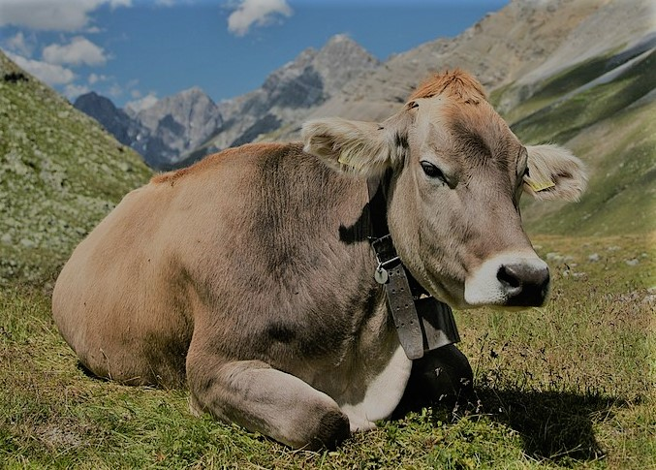

**Conservation Status:**

Domesticated

**Scientific Classification:**

|  |  |
| --- | --- |
| **Kingdom** | Animalia |
| **Phylum** | Chordata |
| **Class** | Mammalia |
| **Order** | Ardiodactyla |
| **Family** | Bovidae |
| **Sub-family** | Bovinae |
| **Genus** | *Bos* |
| **Specie** | *B.taurus* |

|  |
| --- |
| Classification of Birds |

|  |
| --- |
| 1. HEN |

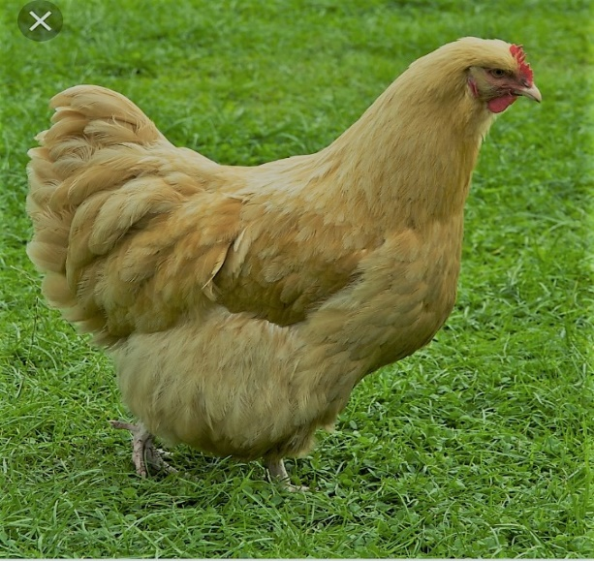

**Conservation Status:**

Domesticated

**Scientific Classification:**

|  |  |
| --- | --- |
| **Kingdom** | Animalia |
| **Phylum** | Chordata |
| **Class** | Aves |
| **Order** | Galliformes |
| **Family** | Phasianidae |
| **Genus** | *Gallius* |
| **Specie** | *G.gallus* |
| **Sub-Specie** | *G.g.domesticus* |

|  |
| --- |
| 1. PIGEON |

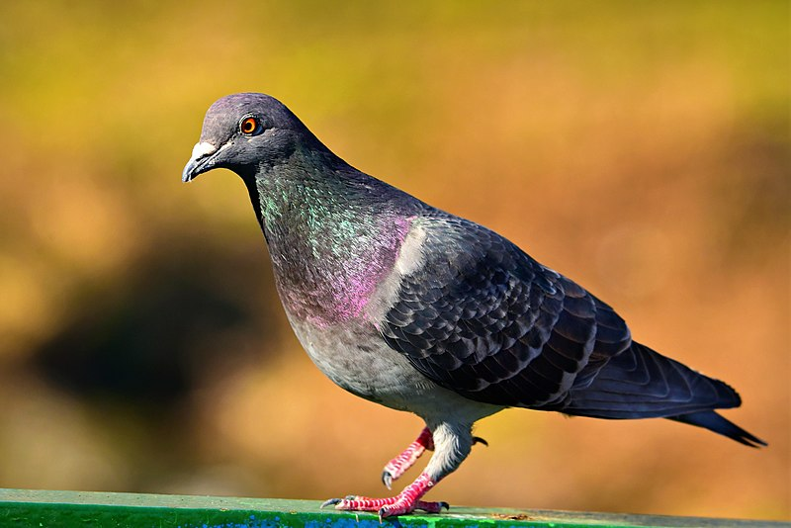

**Conservation Status:**

Domesticated

**Scientific Classification:**

|  |  |
| --- | --- |
| **Kingdom** | Animalia |
| **Phylum** | Chordata |
| **Class** | Aves |
| **Order** | Columbiformes |
| **Family** | Columbitae |
| **Genus** | *Columba* |
| **Specie** | *C.livia* |
| **Sub-Specie** | *C.l.domestica* |

|  |
| --- |
| 1. CROW |

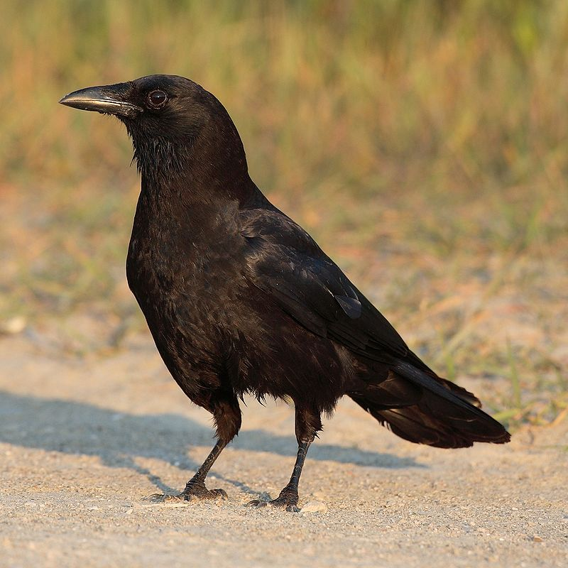

**Conservation Status:**

Least Concern

**Scientific Classification:**

|  |  |
| --- | --- |
| **Kingdom** | Animalia |
| **Phylum** | Chordata |
| **Class** | Aves |
| **Order** | Passeriformes |
| **Family** | Corvidae |
| **Sub-family** | Corvinae |
| **Genus** | *Corvus* |
| **Specie** | *C.brachyrhynchos* |

|  |
| --- |
| 1. EAGLE |

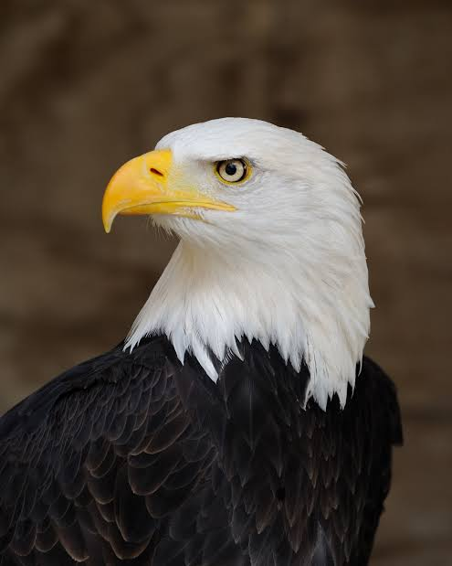

**Conservation Status:**

Least Concern

**Scientific Classification:**

|  |  |
| --- | --- |
| **Kingdom** | Animalia |
| **Phylum** | Chordata |
| **Class** | Aves |
| **Order** | Accipitriformes |
| **Family** | Accipitridae |
| **Sub-family** | Aquilinae |
| **Genus** | *Aquila* |
| **Specie** | *A.chrisaetos* |

|  |
| --- |
| 1. NIGHTINGALE |

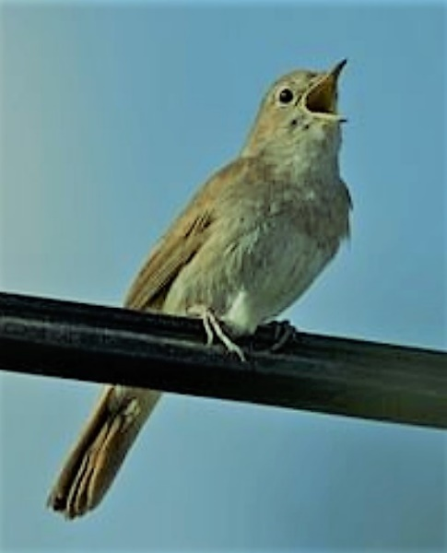

**Conservation Status:**

Least Concern

**Scientific Classification:**

|  |  |
| --- | --- |
| **Kingdom** | Animalia |
| **Phylum** | Chordata |
| **Class** | Aves |
| **Order** | Passeriformes |
| **Sub-order** |  |
| **Family** | Muscicapidae |
| **Sub-family** |  |
| **Genus** | Luscinia |
| **Specie** | L.megarhynchos |

|  |
| --- |
| 1. TIGER |

**Conservation Status:**

Domesticated

**Scientific Classification:**

|  |  |
| --- | --- |
| **Kingdom** |  |
| **Phylum** |  |
| **Class** |  |
| **Order** |  |
| **Sub-order** |  |
| **Family** |  |
| **Sub-family** |  |
| **Genus** |  |
| **Specie** |  |

|  |
| --- |
| 1. TIGER |

**Conservation Status:**

Domesticated

**Scientific Classification:**

|  |  |
| --- | --- |
| **Kingdom** |  |
| **Phylum** |  |
| **Class** |  |
| **Order** |  |
| **Sub-order** |  |
| **Family** |  |
| **Sub-family** |  |
| **Genus** |  |
| **Specie** |  |

|  |
| --- |
| 1. TIGER |

**Conservation Status:**

Domesticated

**Scientific Classification:**

|  |  |
| --- | --- |
| **Kingdom** |  |
| **Phylum** |  |
| **Class** |  |
| **Order** |  |
| **Sub-order** |  |
| **Family** |  |
| **Sub-family** |  |
| **Genus** |  |
| **Specie** |  |

|  |
| --- |
| 1. TIGER |

**Conservation Status:**

Domesticated

**Scientific Classification:**

|  |  |
| --- | --- |
| **Kingdom** |  |
| **Phylum** |  |
| **Class** |  |
| **Order** |  |
| **Sub-order** |  |
| **Family** |  |
| **Sub-family** |  |
| **Genus** |  |
| **Specie** |  |

|  |
| --- |
| 1. TIGER |

**Conservation Status:**

Domesticated

**Scientific Classification:**

|  |  |
| --- | --- |
| **Kingdom** |  |
| **Phylum** |  |
| **Class** |  |
| **Order** |  |
| **Sub-order** |  |
| **Family** |  |
| **Sub-family** |  |
| **Genus** |  |
| **Specie** |  |

|  |
| --- |
| 1. TIGER |

**Conservation Status:**

Domesticated

**Scientific Classification:**

|  |  |
| --- | --- |
| **Kingdom** |  |
| **Phylum** |  |
| **Class** |  |
| **Order** |  |
| **Sub-order** |  |
| **Family** |  |
| **Sub-family** |  |
| **Genus** |  |
| **Specie** |  |

|  |
| --- |
| 1. TIGER |

**Conservation Status:**

Domesticated

**Scientific Classification:**

|  |  |
| --- | --- |
| **Kingdom** |  |
| **Phylum** |  |
| **Class** |  |
| **Order** |  |
| **Sub-order** |  |
| **Family** |  |
| **Sub-family** |  |
| **Genus** |  |
| **Specie** |  |

|  |
| --- |
| 1. TIGER |

**Conservation Status:**

Domesticated

**Scientific Classification:**

|  |  |
| --- | --- |
| **Kingdom** |  |
| **Phylum** |  |
| **Class** |  |
| **Order** |  |
| **Sub-order** |  |
| **Family** |  |
| **Sub-family** |  |
| **Genus** |  |
| **Specie** |  |

|  |
| --- |
| 1. TIGER |

**Conservation Status:**

Domesticated

**Scientific Classification:**

|  |  |
| --- | --- |
| **Kingdom** |  |
| **Phylum** |  |
| **Class** |  |
| **Order** |  |
| **Sub-order** |  |
| **Family** |  |
| **Sub-family** |  |
| **Genus** |  |
| **Specie** |  |

|  |
| --- |
| 1. TIGER |

**Conservation Status:**

Domesticated

**Scientific Classification:**

|  |  |
| --- | --- |
| **Kingdom** |  |
| **Phylum** |  |
| **Class** |  |
| **Order** |  |
| **Sub-order** |  |
| **Family** |  |
| **Sub-family** |  |
| **Genus** |  |
| **Specie** |  |